The Hands-On Clinical Workshops
General Guidelines & Description

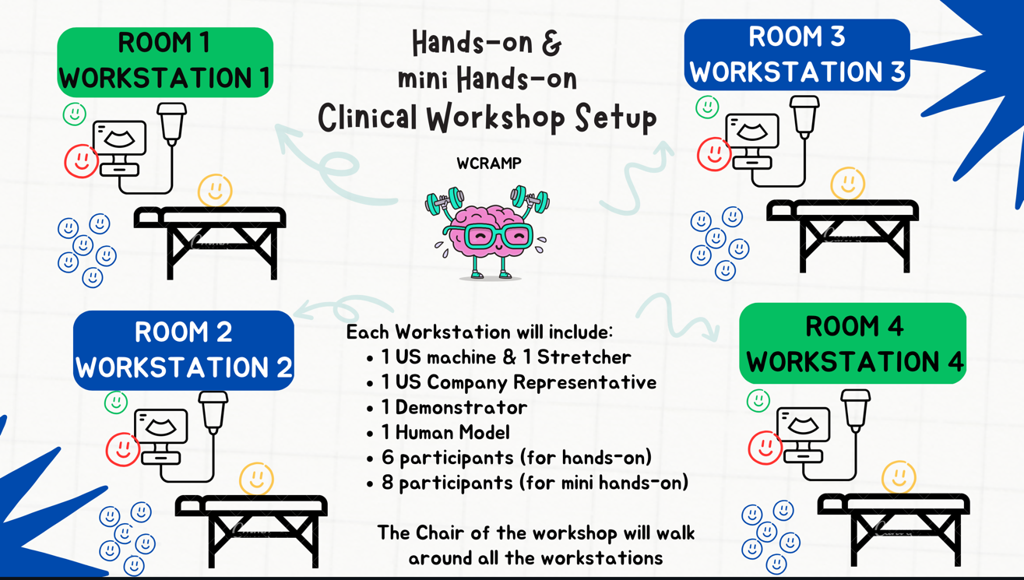

All Hands-on Clinical Workshops will be held in the Congress Center

Definition:

These clinical workshops simulate clinical OR (operation room) or ICU /Emergency
Scenarios, which serve as basis to teach the different ultrasound guided blocks to our delegates.
These workshops are HANDS ON with ACTIVE ultrasound scanning on models by the delegates. This definition is valid for all clinical workshops (adults, paediatrics, chronic pain and POCUS).

Number of Workstations per Workshop:
4 Workstations with different scenarios/topics.
One demonstrator with one US (ultrasound machine). One model per Workstation.

Duration:
2 hours, with 30 min approximately per workstation

Ultrasound – workshop ratio:
4 US with one model each per workshop (1 workshop covers 4 clinical scenarios/topics)

Ultrasound – delegate ratio:
1:6 = max 6 pax per workstation / ideal for a total of 24 delegates

Instructors:
There will be 1 instructor per workstation = 4 demonstrators per workshop

Chairman – Workshop Leader:
There will be one Chairman/Workshop Leader per workshop [usually NOT active (=teaching) involved in the assigned Workshop], But mainly involved in coordination a WS flow

Note:
For the MINI HANDS ON WS, there is only one demonstrator (instructor)
1 US Machine
No chair, An audience of up to 8 delegates for one hour training

Material needed:
- With every US there must be one male or female model!
- Complete US equipment (battery loaded, working connection for power supply)
- Enough gel for all workshops, appropriate towels to clean the US-probe
- One stretcher or other comfortable surface and pillows for positioning the models for a duration of up to 3 hours for scanning them in different positions.
- Enough towels and blankets to cover the models.
- At least one pillow per strecher / model.
- One bathing gown per model (for the time between the workshops, or the models are told to easily removable sport wear).
- Enough paper towels to clean the gel from the models for all workshops Per workstation (1 US, 1 Model, 1 stretcher):
- Water-soluble skin pen to paint on the models.
- 2 chairs per workstation (for instructor and for model between the sessions)

Support from US companies is needed:
At least 1 person per workshop present per US-Company (Sonosite, BK, GE, Mindray etc.) until the instructor feels comfortable with the US.

Projection for presentations:
NOT needed.
Each instructor can take her/his laptop to show in his group some anatomical details but in general there will not be a presentation for all delegates, although this can be modified – all team members need to communicate to each other.

Back – Up:
A back-up of demonstrators is organized to possibly cover unplanned absences or to offer more scenarios for a high number of delegates.

Who to inform in the case of problems?
To avoid delays and other problems, ALL information concerning:
• Problems with models / ultrasounds
• Non-show by demonstrators
• Cancellation by demonstrators prior to the workshop
• Problem with rooms which cannot be solved prior to a
workshop
• Problems with the number of candidates (Workshop is over-booked, need for more instructors etc)

Has to be shared with the following on behalf of the PCO
MCO Congres Group – Amandine Caron - Cell Phone Number: +33(0)627514884

Has to be shared with the following on behalf of ESRA:
Kalliopi Platsi: +30 6945026525

